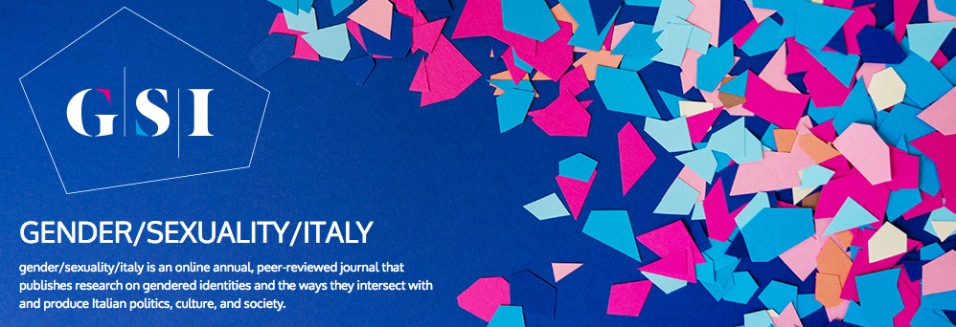


http://www.gendersexualityitaly.com

g/s/i is an annual peer-reviewed journal which publishes research on gendered identities and the ways they intersect with and produce Italian politics, culture, and society by way of a variety of cultural productions, discourses, and practices spanning historical, social, and geopolitical boundaries.

Title: Book Review: Race, Nation and Gender in Modern Italy. Intersectional Representations in Visual Culture by Gaia Giuliani

Journal Issue: gender/sexuality/italy, 7 (2020)

Author: Gianmarco Mancosu

Publication date: December 2020

Publication info: gender/sexuality/italy, “Reviews”

Permalink: http://www.gendersexualityitaly.com/?p=4313

Keywords: Book Review

Copyright information
g/s/i is published online and is an open-access journal. All content, including multimedia files, is freely available without charge to the user or his/her institution and is published according to the Creative Commons License, which does not allow commercial use of published work or its manipulation in derivative forms. Content can be downloaded and cited as specified by the author/s. However, the Editorial Board recommends providing the link to the article (not sharing the PDF) so that the author/s can receive credit for each access to his/her work, which is only published online.
This work is licensed under a Creative Commons Attribution-NonCommercial-NoDerivs 3.0 Unported License
Giuliani, Gaia. Race, Nation and Gender in Modern Italy. Intersectional Representations in Visual Culture. London: Palgrave Macmillan, 2019. Pp. 299. ISBN 978-1-137-50915-4 and 978-1-137-50917-8.
€ 93.59/74.89 (hardcover/eBook).

Gaia Giuliani’s Race, Nation and Gender in Modern Italy. Intersectional Representations in Visual Culture is a powerful book addressing the construction and re-articulation of gendered and racialized representations of national identity in modern Italy. It positions itself in the wake of the recent turn that has occurred in Italian Studies, since the middle of the first decade of the two-thousands. The main aim of this turn is an exploration of national belongings against the backdrop of transnational, postcolonial, and intersectional perspectives. The main purpose of the book is that of retracing the genealogy of racism in Italy today by focusing on the unceasing re-articulation of the colonial archive. Drawing mainly on Ann Stoler’s pivotal definition, this archive is constituted by the set of practices and discourses — or, in Giuliani’s words, figures of race (p. 5) — enabling the interpretation of societies, representations and events from a racialized perspective. Such a vantage point reveals the extent to which racialized bodies have been made either invisible, by silently reproducing the white/racial hegemonic gaze, or hypervisible, when they are represented as dangerous, “monstrous” and, following Nirmal Puwar, as “space invaders.” In fact, the analysis of the protean combination between invisibilization and hypervisibilization is the focal point around which each chapter, and the book as a whole, revolves. This ambitious research endeavor aims to build up a composite framework to read diverse visual discourses through the lens of unproblematized colonial and racial legacies. In so doing, the book effectively points out the persistence of racializing practices in the construction of Italian identity.
Race, Nation and Gender in Modern Italy is organized diachronically, in that it addresses Liberal and Fascist Italy (part 1, chapter 2 and 3), the decades from post-war reconstruction to the seventies (part 2, chapter 4 and 5), and the more recent configuration of Italian society and culture since the eighties (part 3, chapter 6 and 7). Each part features an introduction and two chapters covering a broad range of issues and debates. These discourses and case studies are introduced comprehensively in the first chapter, which provides the critical toolbox for the methodologies that will be used throughout the book. Three are the core-critical themes featured in the first chapter: 1) the colonial archive and the re-articulation of its discursive logic beyond the colonial period; 2) the concept of “race” as a social and discursive construction whose meaning changes over time; 3) the logic of the “encampment,” according to which the “setting of national borders goes hand in hand with defining a nation’s culture and traditions as well as gender, class, race, and rulers/ruled relations” (p. 32). These three concepts are welded together in the analysis of the hetero-referential processes of racialization, which are constructed ‘by contrast’ in relation to the representations of southern/colonial/postcolonial Otherness (mainly chapter 2, 4, 5, 6). On the other hand, Giuliani explores also self-referential processes, that is, the discourses claiming Italians’ white, racial specificity, which were particularly evident after the declaration of the Fascist empire in May 1936 (chapter 3).
Chapter 2 offers a well-substantiated overview of the debates about race in the late nineteenth and early twentieth centuries, by highlighting their instrumentality in the nation-building process, while chapter 3 focuses on the construction of whiteness during the fascist empire in East Africa. Noteworthy is the author’s effort to manage a vast array of secondary sources: part 1 (chapter 2 and 3) embraces a time-span and topics that have been extensively addressed by previous scholarship like the Southern Question and its connection with nation-building, migrations, and early-colonialism; racial and biopolitical discourses during Liberal and Fascist periods. Therefore, the merit of these chapters is that to combine those diverse contributions within an intersectional framework.
Part 2 proposes an examination of the re-articulation of the colonial archive in the aftermath of WWII and up through the seventies. In these years, the construction of Italy’s racial identity shifted from a “linguistically explicit, racist political discourse that permeated the public sphere to an ever expanding, albeit more nuanced, expression of racist perceptions, ideas, and identity constructions in the country’s hegemonic culture” (p. 111). Both chapters 4 and 5 might be seen as the conceptual synthesis of the theoretical reflections unfolding in the book, insofar as they focus on the ambiguous modalities through which documentary films (chapter 4) and erotic movies of the mid-seventies (chapter 5) have adapted the colonial archive and the figures of race in post-colonial and post-fascist contexts. Extremely insightful is the enquiry into the documentaries produced by directors like Pasolini and Rossellini, whose interest in postcolonial processes around the world did not bring them to criticize Italy’s own colonial past. In this context, the analysis of the interplay between voice-over — usually offering a white/male/hegemonic perspective — and images is especially convincing (p. 141). Chapter 5 expands on chapter 4’s results to tackle the attempt to reframe a white “hegemonic culture in its global (tourist, capitalist, and sexually emancipated) dimension” (p. 168) as it surfaced in completely different films, namely erotic and soft-porn production which had a not negligible diffusion in the mid-seventies.
The last part of the book, comprising chapter 6 (about TV shows and commercials of mid-eighties), chapter 7 (about travel TV shows and songs by second-generation migrants of the mid-two-thousands) and the concluding chapter, are concerned with the contemporary configuration of racial issues. Chapter 6 and 7 maintain a substantial continuity with previous chapters insofar as they address TV commercials, TV shows, and songs as sites in which racial patterns are made either hypervisible or invisible in order to strengthen the borders of national belonging (p. 173). However, what is significantly original in these chapters is the attempt to highlight micro-practices of subversion toward hegemonic discourses, as in the case of the songs by Cécile and Bello Figo (p. 224-35). The concluding chapter then condenses the historical and theoretical standpoints of the book, by connecting the various degrees of abjection some groups of people have suffered in Italy’s modern history (southerners, women, the Roma, the poor, the mentally disabled, Jews, the colonized, transgenders, queers) to the nowadays condition of migrant people as they reach the borders of the nation — and, by extension, of the ‘civilized’ world — that is Lampedusa. This is a metaphor for the borders of Italy’s postcolonial society that, according to the author, are still imbued with colonial legacies and by intersecting “colour, gender, class, sexuality, and territorial lines, as well as lines of differential inclusion,” which define who has the right to belong to the body of the nation (p. 249).
Race, Nation and Gender in Modern Italy offers a high-level synthesis of the longstanding work of the author dealing with visual constructions of race and whiteness from an intersectional viewpoint. Giuliani insightfully highlights both continuities and discrepancies among multifaceted visual and discursive phenomena by combining Political Thought, Critical-Whiteness Studies, Postcolonial and Decolonial Theory, and Cultural and Gender Studies. This complex juncture of critical approaches is useful to frame the analysis proposed by Giuliani, yet it requires a certain degree of familiarity both with critical theory and with the topics addressed in the chapters. However, it seems that Giuliani’s choices are motivated both by the complexity of the issues at stake and by the intersectional and long-term perspective she has adopted. Owing to this critical richness, the text would be an extremely valid addition to postgraduate courses in Italian studies, in Sociology, and in Critical Theory, as it offers an acute and refreshing reading of national histories and cultures. Race, Nation and Gender in Modern Italy thus stands as a crucial contribution able to pave the way for future critical works on the intersectional interplay of race, gender, and national belonging in Italy.

GIANMARCO MANCOSU
University of Warwick

